Restorative Thinking – Resources for Schools

All our resources are developed with Head Teachers, teachers, teaching assistants, Governors and Education Psychologists. We regularly review and update our publications and offer support to all schools using our resources via telephone and e-mail. Restorative Thinking Limited is a Social Enterprise and any profits from sales go directly into research, development, editing and writing with and for schools.

(Order form on page 8)

We recommend that teaching staff delivering our resources with pupils have, as a minimum, completed a 1-day restorative practice principles and skills training course with a training provider that holds the TPQM (Training Provider Quality Mark).

Restorative Thinking
Primary School Resources
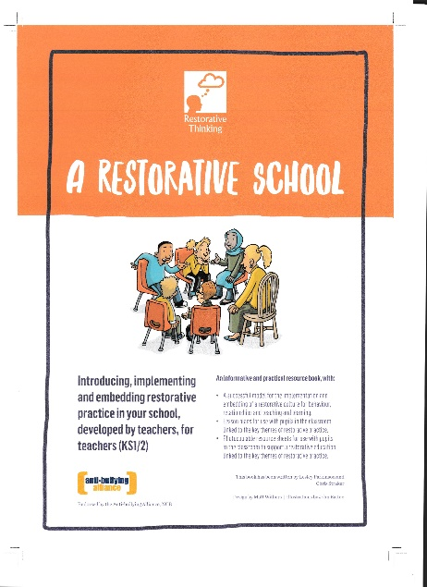

Item | Details | Price
Order code: P1ARS  A Restorative School: Introducing, implementing and embedding restorative practice in your school, developed by teachers, for teachers (KS1/2)  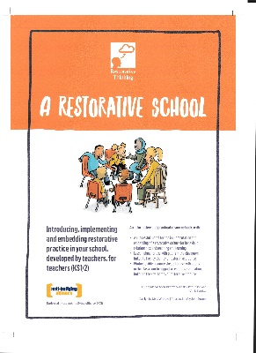 | 53-page A4 booklet with information, lesson ideas and photocopiable resources to support the development of a restorative education in primary and special schools | £50.00 (plus postage)  2020 new edition
Order code: P1BM  Primary bookmarks | Colourful, laminated bookmarks with restorative questions (for pupil and teacher use) | 100 bookmarks:  £53.00 (plus P&P)  200 bookmarks:  93.00 (plus P&P)

Item | Details | Price
Order code: P1TK  Restorative Thinking: A Restorative Practice Curriculum Programme Written by Teachers, for Teachers (KS1 & KS2) | Six-session curriculum programme containing teacher manual, big book, hand puppets, active thinking inflatable ball, bookmarks, talking piece, bag. | £475.00

Restorative Thinking
Secondary School Resources
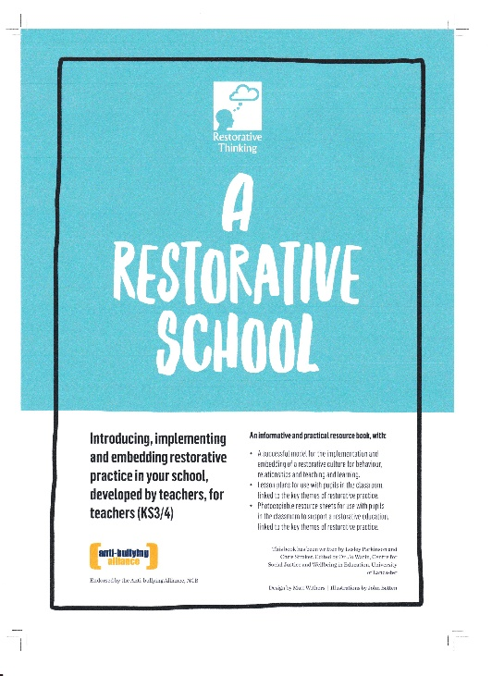

Item | Details | Price
Order code: S2ARS  A Restorative School: Introducing, implementing and embedding restorative practice in your school, developed by teachers, for teachers (KS3/4)  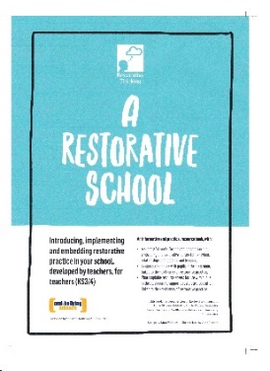 | 72-page A4 booklet with information, lesson ideas and photocopiable resources to support the development of a restorative education in secondary and special schools | £50.00 (plus postage)  2020 new edition
Order code: S2BM  Secondary bookmarks | Colourful, laminated bookmarks with restorative questions (for pupil and teacher use) | 100 bookmarks:  £53.00 (plus P&P)  200 bookmarks:  93.00 (plus P&P)

Item | Details | Price
Order code: S2TK  Restorative Thinking: A Restorative Practice Curriculum Programme Written by Teachers, for Teachers (KS3 & KS4)  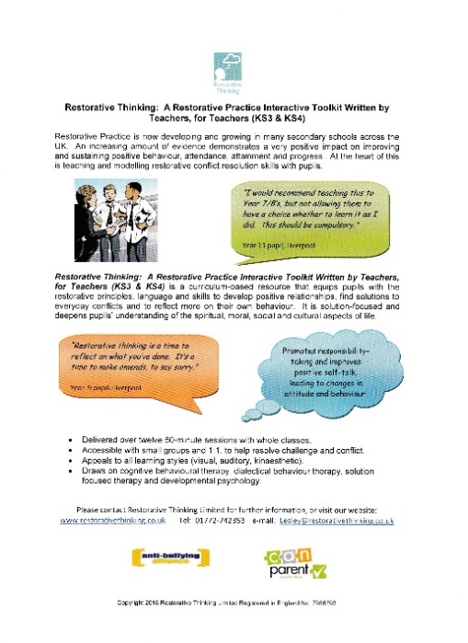 | Twelve-session curriculum programme containing teacher manual, resource book, talking piece, feelings poster, DVD, bookmarks. | £475.00

Name:
Contact number:
School:
I would like to order:
Publication/item | Number of copies | To be delivered to (name and full address):

Delivery is normally within two weeks of order date.
Please e-mail this form to: lesley@restorativethinking.co.uk

